JOIN US IN CELEBRATING DOWN SYNDROME AWARENESS WEEK 20th -26th March
AND WEAR ‘LOTS OF SOCKS’
Down Syndrome Awareness week takes place on 20th-26th March 2017 and incorporates World Down Syndrome Day on Tuesday 21st March. We would love it if your organisation would take part in this year’s celebration to raise awareness of Down syndrome and raise vital funds for your local charity Downright Special.
We would really appreciate it if you would join us, other organisations, schools and nurseries in this area and many other people worldwide in this fun and easy way to raise money and get everyone talking about what it means to have Down syndrome, help raise awareness of what Down syndrome is, and how people with Down syndrome play a vital role in our lives and communities.
We ask that everyone comes to school or work on Tuesday 21st March or (any day during awareness week) wearing lots of brightly coloured, patterned or odd socks and makes a voluntary donation of £1. You could even wear three socks to represent the fact that people with Down syndrome have three copies of chromosome 21!
‘Lots of Socks’ is a worldwide campaign organised by Down Syndrome International for World Down Syndrome Day (https://worlddownsyndromeday.org/). The enclosed information explains the origins of the ‘Lots of Socks’ idea and we have also enclosed some information on how to take part in the event.
The money raised will help us to continue our work supporting children with Down syndrome across Hull and East Yorkshire and in particular will help us to continue our essential work providing specialist advice, resources and training to schools and nurseries on the inclusion of children with Down syndrome.
For more information about what we do then please have a look at our website or if you are interested in other ideas for how you can support us then you can download our fundraising pack: www.downrightspecial.co.uk/fundraising
Many thanks for your support and please don’t hesitate to get in touch if you would like further information.
Kind regards
Gillian Bowlas
Charity Manager

Why Lots of Socks?
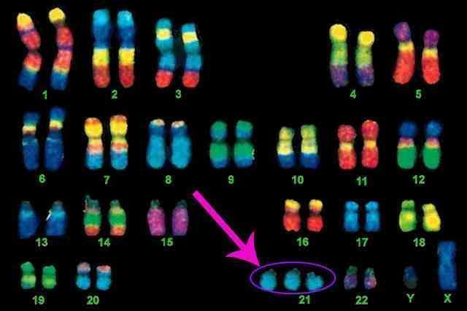

This is a picture of chromosomes which some say look a little bit like pairs of socks. Sometimes people have an extra ‘sock’ or chromosome and a person with Down syndrome has an extra copy of chromosome 21 as you can see in the picture. That’s ok – it just means that some things a little harder for them. They are a little different but different is ok. People with Down syndrome learn, laugh, love, live and, just like the rest of us, sometimes also get cross, sad, dislike things, get uncomfortable being stared at and just want to join in with everyone else. Where children with Down syndrome and other disabilities are given opportunities to join in, all children benefit from this and environments of friendship, acceptance, respect for everyone and high expectations are created.

What to do next
- Let us know that you are taking part by emailing office@downrightspecial.co.uk . Please feel free to ask if you need any other information to help you with the day. We can provide leaflets about Down syndrome, information about Downright Special, collection tins etc. if you would find that useful.

- Ask everyone in your nursery, school, club or workplace to wear their brightest, patterned or odd socks on Tuesday 21st March (or any suitable day during Awareness Week) in exchange for a suggested donation of £1. We have enclosed a leaflet that you can edit and send out asking people to take part.

- Send us your photos - we’d love to see any photos of the day. Email office@downrightspecial.co.uk or post them on social media. You’ll find us on facebook.com/DownrightSpecialNetwork or on Twitter @Downright21. Please use the hashtags #WDSD17 and #lotsofsocks

- Any donations would be very gratefully received in any of the following ways:

  - Send a cheque made out to ‘The Downright Special Network’ to:
The Treasurer
Downright Special
Bodmin Road Church Office
Padstow Close
Hull HU7 4HE
- By BACS:
Sort Code: 40 52 40, Account Number 00024883, Account Name: The Downright Special Network. Please put your organisation’s name in the Reference box.
- Ring us on 01482 420160 and arrange for someone to collect your donation

- We will then send you a ‘Certificate of Appreciation’ that you can display so that we can say a ‘Downright Special’ thank you to everyone involved and acknowledge receipt of your donation.

Thank you so much for your support and we hope you enjoy wearing ‘Lots of Socks’ and celebrating World Down Syndrome Day on 21st March!

